**Practical no 4**

**AIM:** Write and test a program to update 10 student records into table into Excel file using TestNG.

**Theory**

**What is testNG**

TestNG is a testing framework for the Java programming language created by C´edric

Beust and inspired by JUnit and NUnit. The design goal of TestNG is to cover a wider

range of test categories: unit, functional, end-to-end, integration, etc., with more powerful

and easy-to-use functionalities.

**Annotations in TestNG**

**@BeforeSuite:** The annotated method will be run before all tests in this suite have run.

**@AfterSuite**: The annotated method will be run after all tests in this suite have run.

**@BeforeTest**: The annotated method will be run before any test method belonging to

the classes inside the ¡test¿ tag is run.

**@AfterTest**: The annotated method will be run after all the test methods belonging to

the classes inside the ¡test¿ tag have run.

**@Test**: Marks a class or a method as part of the test.

**Jxl Library Functions :**

**Workbook :** Represents a Workbook. Contains the various factory methods and provides a variety of accessors which provide access to the work sheets.

**WritableWorkbook** : A writable workbook.

**Sheet :** Represents a sheet within a workbook. Provides a handle to the individual cells,

or lines of cells (grouped by Row or Column).

**WriteableSheet :** Interface for a worksheet that may be modified. The most important

modification for a sheet is to have cells added to it

**Label :** A cell containing text which may be created by user applications.

**Steps to install TestNG**

Step-1 :- Create a new Project and give it a name.

Step-2 :- After the initialization create a new package inside the project and give it a

name.

Step-3 :- To include the libraries and ”jar” files, Unzip the zipped archives,next ”right

click on the project icon → BuildP ath → Conf igureBuildP ath..”

Step-4 :- Here we will choose ”Add External JARs...” button and navigate to the ”.jar”

file we downloaded/extracted and select them to include in our project.

Step-5 :- To add TestNG to eclipse navigate to help → InstallNewSof tware...

Step-6 :- Next add the TestNG URL

http://dl.bintray.com/testng-team/testng-eclipse-release/ and

save it as a new source in eclipse.

Step-7 :- Wait for the software repository to fetch all the package data.

Step-8 :- Select TestNG package and all of its sub-packages /dependencies.

Step-9 :- Let the package manager calculate and download the dependencies and requirements.

Step-10 :- Accept the License agreement and finish the installation.

Step-11 :- Next to add a TestNG window to eclipse click on window → showview →

java → T estNG.

Step-12 :- Right click on the project and add a new TestNG class to the project with a

suitable name.

Step-13 :- Add the TestNG Library to your project as well.

**Code**

|  |
| --- |
| import java.io.FileInputStream;  import java.io.FileOutputStream;  import org.testng.annotations.Test;  import jxl.*;  import jxl.read.biff.BiffException;  import jxl.write.*;  import jxl.write.biff.RowsExceededException;  import java.io.*;  public class NewTest {    @Test  public void testImportExcel() throws IOException, BiffException , RowsExceededException , WriteException  {  FileInputStream fi = new FileInputStream("E:\\tycs\\stqa prac\\prac4\\Student.xls");  Workbook w = Workbook.getWorkbook(fi);  Sheet s = w.getSheet(0);  String a[][] = new String[s.getRows()][s.getColumns()];  FileOutputStream fo = new FileOutputStream("E:\\tycs\\stqa prac\\prac4\\Output.xls");  WritableWorkbook wwb = Workbook.createWorkbook(fo);  WritableSheet ws = wwb.createSheet("result", 0);  System.out.println("Performed by krunal 713");  for (int i = 0; i < s.getRows(); i++)  {  for (int j = 0; j < s.getColumns(); j++)  {  a[i][j] = s.getCell(j , i).getContents();  Label l2 = new Label(j , i ,a[i][j]);  ws.addCell(l2);  Label l1 = new Label(6 , 0 , "Result");  ws.addCell(l1);  }  }  for (int i = 1; i < s.getRows(); i++)  {  for (int j = 2; j < s.getColumns() ; j++)  {  a[i][j] = s.getCell(j , i).getContents();  int x =Integer.parseInt(a[i][j]);  if(x> 40)  {  Label l1 = new Label(6 , i , "pass");  ws.addCell(l1);  }  else  {  Label l1 = new Label(6 , i , "fail");  ws.addCell(l1);  break;  }  }  }  wwb.write();  wwb.close();  }  } |

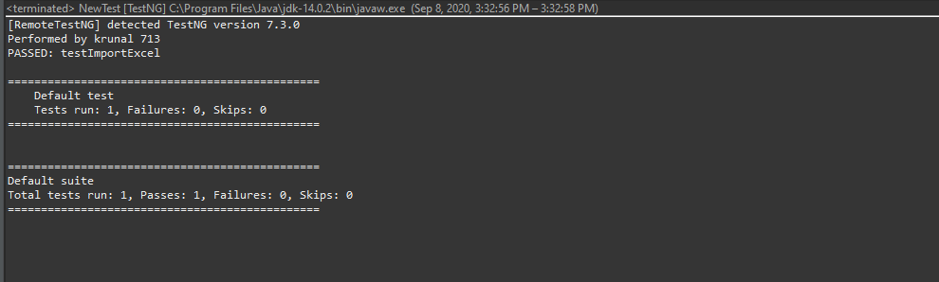

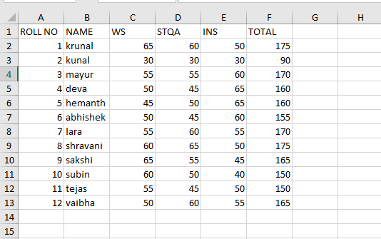

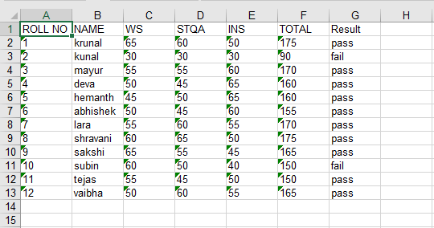

**Date:-** 09/10/2020

**Practical no 5**

**AIM:** Write and test a program to select the number of students who have scored more than 60 in any one subject

**Theory**

**What is testNG**

TestNG is a testing framework for the Java programming language created by C´edric

Beust and inspired by JUnit and NUnit. The design goal of TestNG is to cover a wider

range of test categories: unit, functional, end-to-end, integration, etc., with more powerful

and easy-to-use functionalities.

**Annotations in TestNG**

**@BeforeSuite:** The annotated method will be run before all tests in this suite have run.

**@AfterSuite**: The annotated method will be run after all tests in this suite have run.

**@BeforeTest**: The annotated method will be run before any test method belonging to

the classes inside the ¡test¿ tag is run.

**@AfterTest**: The annotated method will be run after all the test methods belonging to

the classes inside the ¡test¿ tag have run.

**@Test**: Marks a class or a method as part of the test.

**Jxl Library Functions :**

**Workbook :** Represents a Workbook. Contains the various factory methods and provides a variety of accessors which provide access to the work sheets.

**WritableWorkbook** : A writable workbook.

**Sheet :** Represents a sheet within a workbook. Provides a handle to the individual cells,

or lines of cells (grouped by Row or Column).

**WriteableSheet :** Interface for a worksheet that may be modified. The most important

modification for a sheet is to have cells added to it

**Label :** A cell containing text which may be created by user applications.

**Steps to install TestNG**

Step-1 :- Create a new Project and give it a name.

Step-2 :- After the initialization create a new package inside the project and give it a

name.

Step-3 :- To include the libraries and ”jar” files, Unzip the zipped archives,next ”right

click on the project icon → BuildP ath → Conf igureBuildP ath..”

Step-4 :- Here we will choose ”Add External JARs...” button and navigate to the ”.jar”

file we downloaded/extracted and select them to include in our project.

Step-5 :- To add TestNG to eclipse navigate to help → InstallNewSof tware...

Step-6 :- Next add the TestNG URL

http://dl.bintray.com/testng-team/testng-eclipse-release/ and

save it as a new source in eclipse.

Step-7 :- Wait for the software repository to fetch all the package data.

Step-8 :- Select TestNG package and all of its sub-packages /dependencies.

Step-9 :- Let the package manager calculate and download the dependencies and requirements.

Step-10 :- Accept the License agreement and finish the installation.

Step-11 :- Next to add a TestNG window to eclipse click on window → showview →

java → T estNG.

Step-12 :- Right click on the project and add a new TestNG class to the project with a

suitable name.

Step-13 :- Add the TestNG Library to your project as well.

**Code**

|  |
| --- |
| import java.io.FileInputStream;  import java.io.FileOutputStream;  import java.io.IOException;  import org.testng.annotations.Test;  import jxl.Sheet;  import jxl.Workbook;  import jxl.read.biff.BiffException;  import jxl.write.Label;  import jxl.write.WritableSheet;  import jxl.write.WritableWorkbook;  import jxl.write.WriteException;  import jxl.write.biff.RowsExceededException;  public class NewTest {  @Test  public void StudentImport() throws IOException , BiffException , RowsExceededException , WriteException  {  FileInputStream fi = new FileInputStream("E:\\tycs\\stqa prac\\prac5\\Student.xls");  Workbook w = Workbook.getWorkbook(fi);  Sheet s = w.getSheet(0);  String a[][] = new String[s.getRows()][s.getColumns()];  FileOutputStream fo = new FileOutputStream("E:\\tycs\\stqa prac\\prac5\\studentdata.xls ");  WritableWorkbook wwb = Workbook.createWorkbook(fo);  WritableSheet ws = wwb.createSheet("result", 0);  int c=0;  System.out.println("performed by krunal 713");  for (int i = 0; i < s.getRows(); i++)  {  for (int j = 0; j < s.getColumns();  {  if(i >= 1)  {  String b= new String();  b = s.getCell(3,i).getContents();  int x= Integer.parseInt(b);  if( x < 60)  {  c++;  break;  }  }  a[i][j] = s.getCell(j, i).getContents();  Label l2 = new Label(j, i-c, a[i][j]);  ws.addCell(l2);  }  }  wwb.write();  wwb.close();  }  } |

**OUTPUT:**

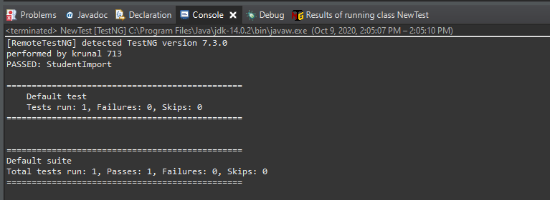



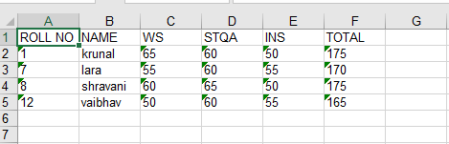

**Part B:-**

**Aim:-** Write and test a program to read the data from product excel sheet and select the products which price is more than 10000.

**Code:-**

|  |
| --- |
| import java.io.FileInputStream;  import java.io.FileOutputStream;  import java.io.IOException;  import org.testng.annotations.Test;  import jxl.Sheet;  import jxl.Workbook;  import jxl.read.biff.BiffException;  import jxl.write.Label;  import jxl.write.WritableSheet;  import jxl.write.WritableWorkbook;  import jxl.write.WriteException;  import jxl.write.biff.RowsExceededException;  public class NewTest {  @Test  public void ProductImport() throws IOException , BiffException , RowsExceededException , WriteException  {  FileInputStream fi = new FileInputStream("E:\\tycs\\stqa prac\\prac5\\product.xls");  Workbook w = Workbook.getWorkbook(fi);  Sheet s = w.getSheet(0);  String a[][] = new String[s.getRows()][s.getColumns()];  FileOutputStream fo = new FileOutputStream("E:\\tycs\\stqa prac\\prac5\\productdata.xls ");  WritableWorkbook wwb = Workbook.createWorkbook(fo);  WritableSheet ws = wwb.createSheet("result", 0);  int c=0;  System.out.println("performed by krunal 713");  for (int i = 0; i < s.getRows(); i++)  {  for (int j = 0; j < s.getColumns();  {  if(i >= 1)  {  String b= new String();  b = s.getCell(3,i).getContents();  int x= Integer.parseInt(b);  if( x < 60)  {  c++;  break;  }  }  a[i][j] = s.getCell(j, i).getContents();  Label l2 = new Label(j, i-c, a[i][j]);  ws.addCell(l2);  }  }  wwb.write();  wwb.close();  }  } |

**Output:**

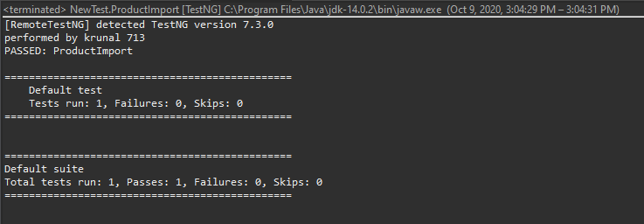

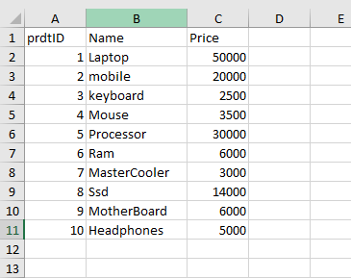

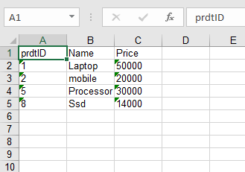

**Date:17/10/2020**

**Practical no 6**

**AIM:** Write and test a program to provide total number of objects present / available on the page

**Theory**

**WebElement** : Represents an HTML element. Generally, all interesting operations to

do with interacting with a page will be performed through this interface.

WebElements objects are Selenium(Java) equivalent of HTML elements in the UI such

as Form, Button, Select, A, P, H0-6, etc..

**java.util.List<WebElement>** : This data structure allows one two list down WebElements in Java which could be sub-elements or nested elements under the selector. The object has methods such as object.size() which returns the size of the list,

object.get(index) which returns a element from the object at a specified index, object.get(index).getText() returns the text of the element.

**WebDriver.findElement() :** Find the first WebElement using the given method.

This method is affected by the ’implicit wait’ times in force at the time of execution. The

findElement(..) invocation will return a matching row, or try again repeatedly until the

configured timeout is reached. findElement should not be used to look for non-present

elements, use findElements(By) and assert zero length response instead.

**By.tagName()** : By is a mechanism used to locate elements within a document from

selenium code. This allows us to access elements by multiple ways such as tag names, ids,

names, class names, etc.. Here we use By.tagName() to select HTML elements through

specified tag name.

**Code:**

|  |
| --- |
| package stqapracccc;  import org.openqa.selenium.By;  import org.openqa.selenium.WebDriver;  import org.openqa.selenium.chrome.ChromeDriver;  import org.openqa.selenium.WebElement;  public class Total_pages {    static String *drivePath* = "E:\\tycs\\stqa prac\\prac2\\chromedriver_win32\\chromedriver.exe";  public static WebDriver *driver*;  public static void main(String[] args) {  System.*setProperty*("webdriver.chrome.driver" , *drivePath*);  *driver* = new ChromeDriver();  *driver*.get("https://practice.geeksforgeeks.org/");  java.util.List<WebElement> link = *driver*.findElements(By.*tagName*("a"));  System.***out***.println("performed by krunal 713");  System.***out***.println("Total links are " + link.size());  for(int i =0; i < link.size() ; i++)  {  System.***out***.println("Link" + i +" Link name "+ link.get(i).getText());  }  System.***out***.println("performed by krunal 713");  *driver*.close();  }  } |

**Output:-**



